Assessing an online Jing MethodTM Advanced Clinical Massage Protocol to treat stress in unpaid carers of children or adults with disability

Casey Stewart-Smith

A dissertation submitted in partial fulfilment of the requirements of Jing Advanced Massage Training for the Professional Diploma in Advanced Clinical Massage and Sports Massage

March 2024

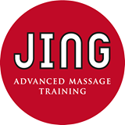

Total word count:3546
“I certify that this work has not been accepted in substance for any degree, and is not concurrently being submitted for any degree other than that of the Diploma in Advanced Clinical Massage and Sports Massage being studied at Jing Advanced Massage Training. I also declare that this work is the result of my own investigations except where otherwise identified by references and that I have not plagiarised the work of others”.

Casey Stewart-Smith
Date: March 2024

Table of Contents
Dedication and acknowledgements 5
Creativity Page 8
Abstract 8
Abbreviations 11
Literature Review 12
What is an unpaid carer? 12
What is stress? 13
Benefits of massage on stress 14
The impact of telehealth 14
The Jing Method TM Advanced Clinical Massage Protocol 16
Method 18
Inclusions 19
Exclusions 19
Control Period 20
Intervention Period 20
Depression, Anxiety, Stress Scales 21 (DASS-21) 21
Results 22
Discussion 28
Findings 28
Unpaid Carers & Carer Burden 28
Telehealth & Online Protocols 29
Jing MethodTM & Teaching Self-Care: the T in HFMAST 30
Limitations & Learnings 31
Conclusion 34
References 35
Bibliography 38
Appendix 1: Ethics Form 44
Appendix 2: Participant letter and recruitment images 50
Appendix 3: Consent Form 53
Appendix 4: DASS-21 Form 54
Appendix 5: Intervention protocol 56
Appendix 6: Intervention timetable 57
Appendix 7: Participant feedback 58
Appendix 8: Breathing technique graphics 62
Appendix 9: Example stills from week 1 intervention (week 7 of study) 63
Appendix 10: Contact Details and downloadable study QR Code 64

Dedication and acknowledgements
This study is dedicated to all unpaid carers you are an inspiration and I am humbly your servant.

Firstly, I would like to thank my amazing supportive family. Completing this work has been an intense experience to say the very least. Danny, my amazing husband has been an absolute rock holding me steadfastly to the ground when my helium filled brain totally wandered off, I thank you wholeheartedly for your undying patience and your confidence in me that I would get it done, for putting up with my sleepless nights and moody mornings and being my confidant when my doubts were overwhelming. To my strong and beautiful goddess daughters, Willow and Inara, I love you so much. Your resilience, strength, kindness and humour are a pure joy; thank you for all the hugs, laughs and gorgeous care. To my Mum Moira Adams and my little sister Harry Adams, thank you for listening, advising and giving me lots of space to just be me and flop when I needed it. To the fluffy whoof, Zero, for getting me out into the sunshine and into the company of other human beings when I can so easily get lost in our little home behind a computer screen.

To John McBride and Fran Birch for helping me decipher data, still blows my mind. To the class of 2024 - thank you for your support and deeply kind care throughout the past 2 years, with extra special thanks to Sian O’Flynn for always checking in on me and helping me when I’ve been stuck. To Cecile DuMont, oh my god, your help has been beyond powerful I am forever grateful and to Tracey Abbott you absolute queen “baby we were born to rock!”

To all my wonderful friends who have put up with my anxiety ridden moments, their constant support and guidance, in-particular Charlize ‘Goddess’ Storm and Suzanne ‘Queen of the world’ Gorman have given so much courage to just be me and not give up.
To the formidable duo Meghan Mari and Rachel Fairweather thank you for following through on those enormous dreams, for creating the space and holding the Jing family in your arms with pure passion, love and endless creativity. Your dynamism is unrivalled and I thank you for your patience and belief that us neuro-spicy humans can dream bravely with the right nurturing. If only the whole UK education system was run on Jing love, what a world that would be. I owe you both my entire career as a massage therapist and I’m so glad that I was guided in that lecture theatre back in 2014 to hear Meg’s cries of ‘we’re massage therapists whoo’ followed by a huge cheer, because it intrigued me so much that I ventured down to your offering and was truly catapulted into the Jing chapter of my life, so far it has exploded, expanded and exulted my curious little brain and heart beyond measure. I am utterly and totally beyond grateful (see I told you it takes me a while to process my thoughts … I’ll bring this with me for my next closing circle!).

To my lovely and incredibly patient Jing tutor Susan Harrison, thank you for your guidance and undying belief that I would get this done. I feel like I might have put you through the ringer, and I’m forever in your debt.

To the Carers Centre Tower Hamlets, thank you for believing in me, supporting me through my studies and trusting me with the honour of providing the best treatments for your amazing clients, I am eternally grateful. Graham Collins, Tony Collins, Farzana Khanom, and everyone who works at the carers centre your work is so needed and so gratefully received.

Lastly but in by no means leastly to all the wonderful Unpaid Carers of Tower Hamlets who inspired this study. It’s an absolute honour and my greatest pleasure to be your massage therapist. I have learnt so much from you, your humility, your kindness, but above all your energy to care as deeply as you do, not just about those under your charge but support for everyone around you too. Through treating you, and getting to know you, I have grown exponentially as a human being and I’m so incredibly grateful for all the lessons and so ready, as always, to learn more.

Creativity Page

It is highly likely that at some point in your life, you will be called upon to become a unpaid carer. To hold the burden on your shoulders that will change everything you thought you knew about yourself and your life. Very rarely it’s something that we plan for.

As your future unfolds, take a moment and give yourself permission to put your own self-care at the very top of your ‘to do’ list so that you can hold yourself in a solid embrace.

You are the most significant factor in the life of the person you are assigned to care for, and as they say, you cannot pour from an empty cup so fill that cup up to full and over flowing
Those around you can then benefit from that overflow and you can find some inner peace.

Abstract
Objective:
This study aims to build on previous studies which have shown positive evidence that providing weekly online massage and self-care, following the principles of The Jing MethodTM Advanced Clinical Protocol, has a positive effect on stress levels in unpaid carers of children or adults with disability.

Method
8 participants agreed to join the 16-week study, with initial levels for eligibility assessed using the Depression, Anxiety and Stress Scale 21 (DASS-21) questionnaire. They were recruited from the researcher’s client base, social media, and through the Carers Centre Tower Hamlets.
Control period: Week 1-6 Participants completed the DASS-21 questionnaire without any treatment. These findings established the group's stress level as a baseline.
Intervention Period: Weeks 7–12 Using a modified Jing MethodTM protocol, weekly guided self-treatment sessions were conducted using the Zoom platform. Every session addressed a distinct area of the body. Four sessions were scheduled over two days were conducted in small groups of no more than five people to allow for flexibility—as the position of carer can be unpredictable.
The DASS-21 questionnaire was used throughout the 14 week project. Weeks 1-6 to establish baseline stress levels and weeks 7-12 during the intervention period, a follow-up was sent at week 14 to assess whether longer-term results. Participants were also encouraged to complete a self-care routine in the intervening period between sessions and were sent a written feedback form to fill in a few weeks later.

Result
All participants showed a marked decreases in levels of depression, anxiety and stress with average decreases by 58.5%, 42% and 50% respectively. Overall DASS-21 scores decreased by 38.7% during the intervention phase.

Conclusion
This research study clearly demonstrates that the adaptation of the Jing MethodTM principals to an online protocol has huge potential and that further investigation to establish optimum intervention levels could be helpful to improve efficiency and may have significant implications for the health and wellness field, including the future possibility of social prescription.

Abbreviations
HFMAST: Heat, Fascia, Muscles, Acupressure, Stretching, Teach
WHO: World Health Organisation
BPS: Biopsychosocial Model
GDPR: General Data Protection Regulation
AIS: Active Isolated Stretching
PNF: Proprioceptive Muscular Facilitation
TA: Therapeutic Alliance

Literature Review

What is an unpaid carer?
An unpaid carer is anyone who provides care for a family member, partner, or friend who requires substantial assistance due to physical illness, disability, frailty, mental ill health or because of alcohol, drug addiction or misuse (Carers UK, 2022). The number of unpaid carers increased by 4.3 million between 2010 and 2020, which represents 12,000 people per day, with those between the ages of 31 and 45 or over 66 providing the highest level of care (Petrillo, 2022).

The term "carer burden" refers to the overall stress that a person feels while providing long-term care for a family member or other close friend (Liu et al., 2020). The consequences of carer burden result in negative change, which includes decreased care provision, decrease in quality of life, physical and psychological health deterioration. Those that live or work in stressful environments have a higher likelihood of many disorders (Yaribeygi et al., 2017) and caregiver burden is linked to lower psychological well-being compared to other caregiving relationships, regardless of care intensity Zhang and Bennett’s (2024). Research suggests unpaid carers are the backbone of long-term care, a fact also supported by (Lorenz-Dant, 2021), and contribute a staggering £445 million to the economy every day – that’s £162 billion per year (Petrillo and Bennett, 2021)

According to Public Health England (Spiers, 2021) there is evidence to suggest that caring should be considered a social determinant of health and that those who provide care have poor mental health, in addition to "carer burden," which includes anxiety, depression, and a low quality of life. This is consistent with earlier studies about the effects of unpaid caregiving on mental health. (Williams, Cullen and Barlow, 2005; Lederman et al., 2019; Lorenz-Dant, 2021; Cloves, 2023)

A reduction in mental well-being also indicates that caregivers are more likely to suffer from musculoskeletal conditions, cardiovascular disease, and cognitive deterioration. Spiers et al. (2021) suggests that breaks from caring are essential in sustaining caring relationships and ensuring that carers have time for their own lives.

What is stress?
According to the latest World Health Organisation (WHO) Report (WHO, 2023) stress can be defined as a state of worry or mental tension caused by a difficult situation. The body can become overloaded due to ongoing environmental demands on the individual, be they physical, physiological, or psychosocial.

The phrase "biopsychosocial model" (BPS), first used by Engel in 1977, postulated that complex interactions between biological, social, and psychological factors are the root cause of disease, suffering, and psychological issues. According to Fairweather and Mari (2015) pain is not a reflection of what is truly occurring in the tissues; rather, it is a brain perception. Gatchel (2007) reported that the BPS model of healthcare was being widely accepted in medical and scientific circles.

Exposure to acute and chronic stress has a broad range of structural effects on the brain and can alter brain morphology, this can have long-term consequences for the neurological system (Cardoner et al., 2023). This lowering of resilience has a negative impact on cognition and good brain function and has highlighted the innate relationship between stress and the immune system. Immune system impairment is more common in those who are under stress. (Yaribeygi et al., 2017)

Benefits of massage on stress
Massage therapy has a long tradition of working not just with the body but with the mind and emotions (Fairweather and Mari, 2015). Taking behavioural measures to lessen stress in the body or workplace promotes optimal bodily and mental functioning. Positive findings regarding the use of massage therapy for treatment of depression were found in randomized controlled studies by Poland (2013) and physical touch has protective effects on physiological stress responses (Dreisoerner et al., 2021)

Significant improvements in physical and psychological ratings were identified in a 2005 evaluation study given to carers (Mackereth et al., 2005) and in 2014, an evaluation of the NHS complimentary service revealed a 30% perceived improvement in symptoms, including wellbeing (Briscoe and Browne, 2014).

Additional proof that massage therapy can be an effective treatment for stress and depression can be found in a number of small-scale research studies conducted by the Jing Institute of Massage & Complementary Medicine (Aherin, 2023; Jones-Morris, 2021; Mitchell, 2023).

The impact of telehealth
Early reports during the Covid-19 pandemic showed that care-workers suffered from high rates of depression and anxiety (Gray et al., 2020). In a demographic shift in the uses of health services during this time, technology has become more widely seen as being a more affordable option for health care in many spheres of society, and caregivers should be given first priority while using telehealth. (Sharma et al., 2022). Telehealth, an innovative method to healthcare delivery, is a cost-effective strategy to address the needs of those who have been impacted by the economic dynamics of the last 10 years (Aboagye et al., 2022). In a scoping review of the Covid-19 pandemic there is compelling evidence to suggest that telehealth may have a significant effect on advancing health care in the future (Doraiswamy et al., 2020).

A carers' qualitative evaluation revealed that online program's content and delivery were satisfactory, and that they liked the therapist-patient contact (Liberati et al., 2021). A growing body of research has demonstrated the effectiveness of carer engagement and self-management strategies in delivering long-term care to those with chronic illnesses (Forducey, 2012). Cases where people are unable to receive in-person treatments from a massage therapist can also be taught to clients who can learn to self-massage. In a 2018 national survey of massage therapy, professionals’ self-massage was discovered to be the most often discussed subject regarding health promotion amongst massage therapists and clients (Lempke, 2021).
As cost is a barrier to accessing hands on massage therapy as quality care, the teaching of personal self-care techniques could be beneficial to all. Over 25% of carers said that they were having difficulty making ends meet (Carers UK, 2022). Carers concurred that their bodily and/or mental health was suffering as a result of rising living expenses.

These findings suggest that online treatments sessions could be a cost-effective tool for unpaid carers to manage their mental health. Time and money constraints may make receiving hands-on care difficult and while the advantages of hands-on treatment, at present, cannot be replaced by an online treatment protocol, the adaptation of the most crucial element of the the Jing MethodTM HFMAST protocol, T for Teach, has promising results (Aherin, 2023; Cloves, 2023; Mitchell, 2023). After participants grasp the principles, self-care has the potential to develop into a fulfilling lifetime skill that can enhance the health and well-being of unpaid carers.

Engaging in self-care through telehealth empowers individuals to take an active role in managing their well-being. It fosters a sense of autonomy and personal responsibility for health and mental well-being, as individuals have greater control over their self-care journey.

Compared to in-person treatments, telehealth self-care sessions could be comparatively less expensive. Access to pre-recorded material could also help to embed practice. The long term health benefit potential is incredibly important to investigate and can only be enhanced by a therapeutic alliance. Building a relationship with the caregiver with a tailored and personal approach is recommended (Liberati et al., 2021).

During the Covid-19 pandemic, the researcher held online group sessions for carers involved with Tower Hamlets Carers Centre. The researcher was employed as a single therapist to deliver online self-care for one hour per week for 4 months. This session had open access to more than 500 unpaid carers for one initial cost to the care provider. As many other services were closed at this time all sessions were well attended, and carers reported back anecdotally that they highly valued the sessions and that they had helped them to prioritise time to look after themselves.

The Jing Method TM Advanced Clinical Massage Protocol

The Jing MethodTM is an outcome-based strategy for treating systemic illnesses and chronic pain. It is a multimodal approach which combines therapeutic alliance, BPS and bodywork methods from the East and the West in 6 separate holistic stages which can be summarised by the mnemonic HFMAST.

H: Heat: Applying heat or using cold. This establishes the groundwork for therapeutic massage methods such as trigger point therapy, fascial work, and stretching to enhance outcomes.
F: Fascia: Advanced myofascial release techniques, both direct and indirect, can be used to decrease stress or discomfort in the body.
M: Muscles: Applying precision trigger point therapy to muscles: Targeting all the muscles surrounding the injury or pain in order to release trigger points.
A: Acupressure: Treating relevant Acupressure points.
S: Stretching: Using AIS, PNF, and Passive Stretching, stretch all muscles treated in the session.
T: Teach: Using Self-Care strategies that lie within the therapist scope of practice to empower individuals within their own wellness journey.

It has been shown that the Jing MethodTM can be adapted to an online self-care protocol that was shown to reduce stress, anxiety, and depression with one study aimed specifically at unpaid carers (Cloves, 2023). However, further research is necessary to produce more conclusive evidence.

Method
The Jing Institute of Advanced Massage Training granted ethical approval for the study using the DASS-21 form to gather data (Appendix 1). Participants for this project were recruited via The Carers Centre Tower Hamlets, carer support groups, social media platforms, and through regular clients who met the criteria. Initial contact was through advertisements and personal contact. Online one-to-ones were then conducted using the Zoom platform where the researcher explained the study, asked a series of questions to determine eligibility, and obtained consent.
A GDPR compliant online booking system was used to enhance a professional feel. Confirmation, reminders, links to DASS-21 form, and follow up self-care videos were sent to all participants using the Acuity Scheduling program. This helped create a streamlined easy-to-access platform, provided a valuable resource and helped the participants feel supported throughout the project.
To help build therapeutic alliance, participants were put into small groups of no more than 5 participants per group spread out over 2 days, and 4 sessions. This also gave an element of flexibility to the participants as their caregiving roles can be unpredictable in nature. If they weren’t able to attend their allotted session, they had the option of catching up on a later call.
All sessions were recorded and participants had options to turn their cameras off. Written permission was gained for recording of the session and were subsequently uploaded to youtube.com and a private link was shared with the group and deleted once the study was completed.

The criteria for participants were as follows:

Inclusions
Registered Unpaid Carer
Adults over 18 years of age of any gender
Experiencing symptoms of stress
Able to access the DASS-21 questionnaire via Jotform.com
Able to access Zoom platform with good internet service
Able to attend weekly 45-minute Online treatment session at allotted time

Exclusions
Not able to access the Zoom platform
Unable to commit to the dates for online study
Currently receiving treatment for their stress
Participants might be excluded from the study if they started any new medication or therapy within the 8 weeks prior to the study starting
Unpaid carers who had planned respite were not excluded but were asked to record how many days they received respite if this was different to the 6-week control period

In addition to using the Jing MethodTM throughout the trial, participants were required to disclose to the researcher any manual therapy, medicine, or other intervention (such as talk therapy) they had received for stress.

Control Period
Participants were required to complete the DASS-21 questionnaire once every Sunday for six weeks without any treatment. These findings established the group's stress level as a baseline. (appendix 4)

Intervention Period
Weeks 7-12 involved weekly online sessions of Jing MethodTM guided self-treatment via Zoom (see Protocol appendix 5). Each session focused on a different body area. They took place on Mondays and Tuesdays at 10am and 7pm. Group sizes were purposefully limited to 5 participants to help build therapeutic alliance.
The participants were also asked to complete the DASS-21 questionnaire on the 7th day following each treatment session, prior to the next session taking place. The final questionnaire was completed on the 7th day after the final treatment and returned to the therapist. A follow-up questionnaire was sent at week 14 to assess whether there were any longer-term results. A verbal feedback form was sent a few weeks later to record anecdotal evidence.
Thirteen people expressed an interest in the study and 10 were suitable to participate. One dropped out due to heightened anxiety levels regarding accessing the sessions online and one had to withdraw in week 8 due to an emergency situation caused by her caregiver role.
Study completion was achieved by 8 participants.

Depression, Anxiety, Stress Scales 21 (DASS-21)
42 questions make up the initial DASS questionnaire created by Lovibond & Lovibond (1995). The University of New South Wales created the DASS to assess people's levels of stress, anxiety, and depression using a Likert scale. The scores for the relevant questions are added up to determine the scores for depression, anxiety, and stress. Time is a huge constraint for participants of this study so the researcher chose to use the abbreviated version, the DASS-21.
The online sessions followed the Jing MethodTM HFMAST elements and focused on a different body part each week (appendix 5). Self-care exercises were shown to the participants at the end of the session and a pre-recording of the self-care was provided to participants each week during the intervention period so that they could follow it. The self-care took no more than 10 minutes to complete. Participants were asked to carry these out 3 times during the week, between the treatment sessions. Compliance of self-care was not compulsory but participants were asked a tick box question that was sent along with the DASS-21 questionnaire to assess how often it was performed each week. For research purposes the Zoom sessions were recorded by the researcher. Participants were requested not to record the online sessions to respect the privacy of all others involved in the study.

Results
DASS 21 Severity Ratings

Severity Level | Depression | Anxiety | Stress
Normal | 0-4 | 0-3 | 0-7
Mild | 5-6 | 4-5 | 8-9
Moderate | 7-10 | 6-7 | 10-12
Severe | 11-13 | 8-9 | 13-16
Extremely Severe | 14+ | 10+ | 17+

The sub-scale's total score on the questionnaire is compared to every DASS-21 severity level. The outcomes of each participant's DASS-21 scores during the trial were analysed using this table. These findings demonstrate the impact that these problems are having on the person's life.

Figure 1 Trend Line 1 Overall DASS-21 Score for the Control and Intervention Period

When comparing the control period to the intervention period, the trend line shows overall DASS-21 scores reduced from 25.8 points to 15.8 points by week 12, the graph demonstrates an overall decrease in DASS-21 levels by 10 points which represents an overall decrease of 38.7%.

During the control period, the overall average DASS-21 score was 26.4. During the intervention period, the overall average DASS-21 score was 18.3, this indicates an average overall decrease in all categories by 8.1 points which represents an overall average decrease of 30%.

Figure 2: DASS-21 Depression Score for the Control and Intervention Period

When comparing the control period to the intervention period, the trend line shows depression scores reduced from moderate levels to mild levels by week 12, levels were reduced further by week 16. The graph demonstrates an overall decrease in depression levels by 5.2 points. Which represents a decrease in depression of 58.5%.

During the control period, the average DASS-21 score for depression was 8.3. During the intervention period, the average DASS-21 depression score was 5.8, this indicates an average decrease in anxiety by 2.5 points.

Figure 3: DASS-21 Anxiety Score for Control and Intervention Period

When comparing the control period to the intervention period, the trend line shows anxiety scores reduced from moderate levels to mild by week 8, with sustained results until week 16. The graph demonstrates an overall decrease in anxiety levels by 3.9 points. Which represents an decrease anxiety of 42%.

During the control period, the average DASS-21 score for anxiety was 7.4. During the intervention period, the average DASS-21 anxiety score was 4.7, this indicates an average decrease in anxiety by 2.7 points.

Figure 4: DASS-21 Stress Score for Control and Intervention Period

When comparing the control period to the intervention period, the trend line shows stress scores reduced from moderate levels to normal by week 10 of the study, with levels continuing to decrease by week 16. The graph demonstrates an overall decrease in stress levels by 5.4 points. Which represents a decrease in stress of 50%.

During the control period, the average DASS-21 score for stress was 10.6. During the intervention period, the average DASS-21 stress score was 7.7, this indicates an average decrease in stress by 2.9 points.
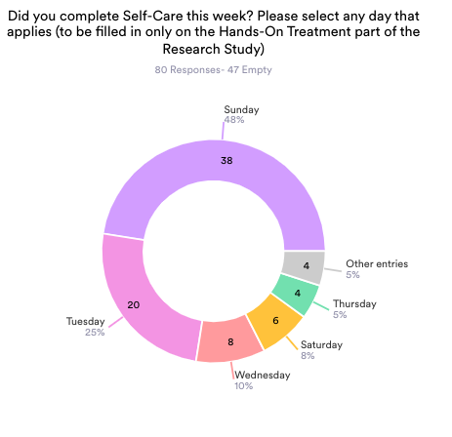

The weekly uptake of the self-care exercises was 80 responses out of a possible 127. With Sunday seemingly the most opportune time for the participants. This indicated that they were motivated to care for themselves between the online sessions. This is thought to have added to the positive outcome achieved in reduction of depression, anxiety and stress.

Discussion

Findings
This study set out to assess the efficacy of the online adaptation of the Jing MethodTM of advanced clinical massage protocol to treat stress in unpaid carers of children or adults with disability. Results were overwhelmingly positive with a decrease across all aspects of the chosen design - depression by 58.5 %, Anxiety by 42% and Stress by 50%. Anecdotal evidence also suggested that unpaid carers felt empowered and supported during the sessions as a result of the new skills they had learned; this reduced everyday stress and had long-lasting impacts. All participants expressed an interest in continuing with the programme to add to their personal skills and would recommend the study to fellow carers and /or friends and family. (appendix 7)
These results build on and add to previous studies that demonstrated the potential for longer-lasting benefits in reducing stress through the use of an online protocol based on the Jing Method™ multi-modal approach (Aherin, 2023; Cloves, 2023; Mitchell, 2023). Ahern’s research (2023) was particularly efficient at highlighting the beneficial effects of the online Jing Method™ and showed overall improvement in the mental health of 92.31% of participants. Stress levels, in particular, decreased by 58%. Further evidence was found in the small-scale study by Cloves (2023) which reported that having weekly online self-care was highly beneficial and helped participants to feel supported.

Unpaid Carers & Carer Burden
Despite their enormous contribution, carers feel undervalued, unsupported and suffer with poor mental health (carers uk, 2022). It would be impossible for our health and care systems to function at all without the high calibre of care that volunteers give. Poor mental health has profound economic consequences as demonstrated by McDaid David (2019) and census data shows use increase in the value of unpaid care is consistent across different areas in England and Wales. (Petrillo and Bennett, 2021)

In response to the question, "What was the most important thing learned from this course?" the participants said that setting aside time for self-care and wellness activities was crucial in lowering their stress levels as unpaid carers. (appendix 7)

Telehealth & Online Protocols
The ease of use of the Zoom platform for this study meant that the carers who often struggle to get to in-person sessions or find time for themselves were able to benefit from the teachings they may not have otherwise been able to access. This is a strong argument for future research and will make access to care less strenuous for all involved. It supports the theory that a range of intervention initiatives must be developed to include technology, Lorenz-Dant (2021) to inspire carers to engage in regular community participation (Kim, 2017).

Anecdotal feedback collected during the study revealed that participants enjoyed the study and felt they would benefit from continuing to learn self-care practices. They also benefited from flexibility within the study's allotted hours and the ability to choose a time and date that suited their personal situation. (See Appendix 7)

The zoom platform also gives the carer some flexibility since they might not have regular access to time off from their caring responsibilities. Another option is to make use of a recommended sequence of pre-recorded self-care programmes.

Though it does pose some challenges, the zoom platform offers an element of flexibility for the care giver as they potentially don’t have access to regular respite away from their caring role. A suggested series of pre-recorded self-care programmes could also be utilised (Lederman et al., 2019; Liberati et al., 2021; Aherin, 2023).

The COVID-19 pandemic has had an impact on many people's mental and psychological health. Young people, women, and residents in underprivileged communities were the most impacted (Bhugra, Molodynski and Gnanapragasam, 2021). In order to address this new wave of mental health issues, mental health services must prioritise serving women, younger adults, and residents of more impoverished locations (Gray et al., 2020).

This study adds to evidence from previous work that creating a solid TA between practitioner and participant is imperative as this helps to empower individuals to take control of their own healing. This can be demonstrated by participants' dedication to practicing both throughout and after the study; this feedback indicates that the curriculum was delivered in a clear and well-designed manner which leads to string overall outcomes (Appendix 7). Further evidence that a strong TA can improve outcomes of individuals participating in physical therapy for chronic musculoskeletal pain outcomes can be found in a systemic literature review conducted by Kinney et al (2020)

Jing MethodTM & Teaching Self-Care: the T in HFMAST
Although receiving hands-on care may always aim for a more durable outcome, mastering self-care techniques will always be empowering. This study adds to our knowledge that teaching self-care, as part of HFMAST protocol, is an integral element of being able to fully support participants through their self-healing process.

The results also help to cultivate TA to empower participants to understand their own mind body connections and how this impacts the level of stress they are feeling in their body. Previous studies find that teaching aspects of self-care to participants online can have an empowering, positive and potentially lasting impact on their health and well-being (Meyrick, 2017; Jones-Morris, 2021; Aherin, 2023; Mitchell, 2023).

This study provides more proof that TA and ACMT ought to be the cornerstones of the health and wellness programme (Jones-Morris, 2021). In situations when access to in-person therapy may not be financially feasible, it may prove to be an indispensable tool for social prescribing. Online self-care has the potential to revolutionise the way health services are provided.

Limitations & Learnings
This project is relatively easy to replicate and has the potential to be life changing for participants as well as affirming for any therapist wanting to continue the study. There are things to consider and adapt for future projects to elevate any future success.

Sample size
Even though the study was successful, a major drawback was the quantity and diversity of participants (8) 7/1 female and male aged between 40-79. There is a clear need for more study with a bigger sample size that consists of participants from all demographic backgrounds, ages and genders.

Method
Although the DASS-21 was quick and easy to use for participants and they remained engaged throughout the project, the participants expressed their opinion that the form lacked sufficient depth to provide a comprehensive understanding of their overall emotional state. The DASS-42, a more extensive version of the DAS scale as it contains 42 questions, might be a better instrument for further studies and provide a wider depth to categorise the information gathered. A standardised questionnaire with opportunity for the carer to reflect and write their true feelings could be beneficial.

While giving the participants their autonomy back was a key component of this study in order to give them a greater sense of control over their recovery, involvement in the after-care practice was optional, which meant there was a chance to build on the promising findings that was lost. For future studies this aspect could be mandatory which could potentially give a broader view of the overall impact of the self-care model.

Researcher’s personal notes
Anyone choosing to continue this study should allow plenty of time to recruit a significant number of participants and should take into account that building a strong TA with them is crucial to participants engaging well with the study and committing to give the feedback needed.

Less is more when it comes to the programme itself. Anecdotal data points to a slower-paced session with repeated instruction and dissemination of the material, giving the newly acquired skills more time to become ingrained. Being clear and precise with delivery of the course and providing them with little more than they expect will help your retention rate. (See Appendix 7)

To convey a sense of ease and professionalism, it is essential to set aside time to evaluate the online platforms and booking system software to ensure that all the relevant information is being given to the client on time and in order.

Giving the carers access to video recordings of the whole session could also be more beneficial for each client than a short ten-minute self-care video as the client can then spend more time imbedding the practice.

Conclusion

The successful results of this study with a decrease across all aspects of the chosen design - depression by 58.5 %, Anxiety by 42% and Stress by 50% show that the adaptation of the Jing MethodTM to an online protocol has huge potential. Further investigation to establish optimum intervention levels could be helpful to improve efficiency and may have significant implications for the health and wellness field, including the possibility of social prescribing.

If future researchers collaborated to build a study with a larger group that reflected a wider and more diversified demographic reaching out to numerous places throughout the country, this project may have an extraordinarily large impact. Being seen, heard, supported and valued as an unpaid carer in society should be our highest priority and extending this study could create a ripple effect resulting in a shift in consciousness around empowerment through self-advocacy, the ramifications for unpaid carers from all backgrounds could be life altering.

As a personal note the researcher found this work extremely rewarding not only in seeing the engagement and positive results, but it also had a profound impact on her own mental health and well-being. Taking time to build and practice the programme, the weekly connection and kind feedback all helped to solidify her understanding of the need for connection, empowerment and the sharing of self-care knowledge.

References
Aboagye, E. et al. (2022) ‘Manual therapy versus advice to stay active for nonspecific back and/or neck pain: a cost-effectiveness analysis’, Chiropractic and Manual Therapies, 30(1). Available at: https://doi.org/10.1186/s12998-022-00431-7.
Aherin, B.R. (2023) The Effects of the Online Jing MethodTM of Advanced Clinical Massage on Mental Health in Adults. Dissertation. Jing Advanced Massage Training: Brighton.
Bhugra, D., Molodynski, A. and Gnanapragasam, S. (2021) ‘COVID-19 pandemic, mental health care, and the UK’, Industrial Psychiatry Journal, 30(3), p. 5. Available at: https://doi.org/10.4103/0972-6748.328862.
Briscoe, J. and Browne, N. (2014) ‘EVALUATING AN NHS COMPLEMENTARY THERAPIES SERVICE’, BMJ Supportive & Palliative Care, 4(1). Available at: https://doi.org/10.1136/bmjspcare-2014-000653.4.
Cardoner, N. et al. (2023) ‘Impact of Stress on Brain Morphology: Insights into Structural Biomarkers of Stress-related Disorders’, Current Neuropharmacology, 22(5), pp. 935–962. Available at: https://doi.org/10.2174/1570159x21666230703091435.
Carers uk (2022) State of caring report 2022. London. Available at: https://www.carersuk.org/media/p4kblx5n/cukstateofcaring2022report.pdf (Accessed: 5 July 2023).
Cloves, A. (2023) Assessing an online Jing Method TM Advanced Clinical Massage Protocol to treat stress in parent carers of children or adults with disability.
Doraiswamy, S. et al. (2020) ‘Use of Telehealth During the COVID-19 Pandemic: Scoping Review’, Journal of Medical Internet Research, 22(12), p. e24087. Available at: https://doi.org/10.2196/24087.
Dreisoerner, A. et al. (2021) ‘Self-soothing touch and being hugged reduce cortisol responses to stress: A randomized controlled trial on stress, physical touch, and social identity’, in Comprehensive Psychoneuroendocrinology. Elsevier Ltd. Available at: https://doi.org/10.1016/j.cpnec.2021.100091.
Forducey, P.G., G.R.L., B.T.F., M.M.M., & Y.M. (2012) ‘Telehealth for persons with severe functional disabilities and their caregivers: Facilitating self-care management in the home setting.’, Psychological Services, 9(2), 144–162., pp. 144–162.
Gatchel, R.J., P.Y.B., P.M.L., F.P.N. and T.D.C. (2007) ‘The biopsychosocial approach to chronic pain: Scientific advances and future directions. ’, Psychological Bulletin, pp. 581–624.
Gray, N.S. et al. (2020) ‘The Influence of the COVID-19 Pandemic on Mental Well-Being and Psychological Distress: Impact Upon a Single Country’, Frontiers in Psychiatry, 11. Available at: https://doi.org/10.3389/fpsyt.2020.594115.
Jones-Morris, L. (2021) Effect of the Jing method of Advanced Clinical Massage on non-specific low back pain and anxiety in Community Midwives.
Kim, D.J. (2017) ‘Relationships between Caregiving Stress, Depression, and Self-Esteem in Family Caregivers of Adults with a Disability’, Occupational Therapy International, 2017. Available at: https://doi.org/10.1155/2017/1686143.
Kinney, M. et al. (2020) ‘The impact of therapeutic alliance in physical therapy for chronic musculoskeletal pain: A systematic review of the literature’, Physiotherapy Theory and Practice. Available at: https://doi.org/10.1080/09593985.2018.1516015.
Lederman, R. et al. (2019) ‘Support for carers of young people with mental illness: Design and trial of a technology-mediated therapy’, ACM Transactions on Computer-Human Interaction, 26(1). Available at: https://doi.org/10.1145/3301421.
Liberati, E. et al. (2021) ‘Remote care for mental health: qualitative study with service users, carers and staff during the COVID-19 pandemic’, BMJ Open, 11(4), p. e049210. Available at: https://doi.org/10.1136/BMJOPEN-2021-049210.
Lorenz-Dant, K. and C.-H.A. (2021) ‘The impacts of COVID-19 on unpaid carers of adults with long-term care needs and measures to address these impacts: a rapid review of evidence up to November 2020. ’, Journal of Long-Term Care, pp. 124–153.
McDaid David, P.A.W.K. (2019) ‘The economic case for the prevention of mental illness’. London School of economics, pp. 373–89.
Meyrick, M. (2017) Evaluating the effects of clinical massage treatment on perceived stress levels in self-employed women. Dissertation. Jing Advanced Massage Training: Brighton.
Mitchell, E. (2023) Evaluating the efficacy of the Jing Method of Advanced Clinical Massage online to treat menopause symptoms. Dissertation. Jing Advanced Massage Training: Brighton.
Petrillo, M.; and Bennett, M.R. (2021) Valuing Carers 2021. Available at: https://centreforcare.ac.uk/publications/valuing-carers-2021/.
Poland, R.E., G.L., F.J.T., S.S.I., M.J.M., R.U., & D.E.S. (2013) ‘Open-label, randomized, parallel-group controlled clinical trial of massage for treatment of depression in HIV-infected subjects’, The Journal of Alternative and Complementary Medicine, pp. 334-340.
Rachel Fairweather and Megan Mari (2015) Massage Fusion: The Jing Method for the Treatment of Chronic Pain. 1st edn. brighton: Handspring publishing .
Sharma, P. et al. (2022) ‘USING TECHNOLOGY ACCEPTANCE MODEL, ANALYZING THE ROLE OF TELEHEALTH SERVICES IN THE HEALTHCARE INDUSTRY DURING COVID-19’, in Asia Pacific Journal of Health Management. Available at: https://doi.org/10.24083/apjhm.v17i2.1815.
Spiers, G., L.J., S.D., W.O., K.P., B.F., C.D., R.S. and H.B. (2021) Caring as a social determinant of health Findings from a rapid review of reviews and analysis of the GP Patient Survey Report and key findings.
Williams, H.L., Cullen, L.A. and Barlow, J.H. (2005) ‘The psychological well-being and self-efficacy of carers of children with disabilities following attendance on a Simple Massage Training and Support Programme: A 12-month comparison study of adherers and non-adherers’, Complementary Therapies in Medicine, 13(2). Available at: https://doi.org/10.1016/j.ctim.2005.03.007.
Yaribeygi, H. et al. (2017) ‘The impact of stress on body function: A review’, EXCLI Journal. Leibniz Research Centre for Working Environment and Human Factors, pp. 1057–1072. Available at: https://doi.org/10.17179/excli2017-480.
Zhang, Y. and Bennett, M.R. (no date) ‘Insights Into Informal Caregivers’ Well-being: A Longitudinal Analysis of Care Intensity, Care Location, and Care Relationship’, The Journals of Gerontology, Series B: Psychological Sciences and Social Sciences, 2024(2), pp. 1–12. Available at: https://doi.org/10.1093/geronb/gbad166.

Bibliography

Aboagye, E., Lilje, S., Bengtsson, C., Peterson, A., Persson, U., & Skillgate, E. (2022). Manual therapy versus advice to stay active for nonspecific back and/or neck pain: a cost-effectiveness analysis. Chiropractic and Manual Therapies, 30(1). https://doi.org/10.1186/s12998-022-00431-7
Al Enazi, A., (2023) The economic impact of our mental health crisis. Investors Chronicle. [online] 4 Oct. Available at: https://www.investorschronicle.co.uk/news/2023/10/04/what-our-mental-health-crisis-means-for-the-economy [Accessed 4 March 2024].
Aherin, B. R. (2023). The Effects of the Online Jing MethodTM of Advanced Clinical Massage on Mental Health in Adults. Dissertation. Jing Advanced Massage Training: Brighton.
Al Omari, O., Al Sabei, S., Al Rawajfah, O., Abu Sharour, L., Aljohani, K., Alomari, K., Shkman, L., Al Dameery, K., Saifan, A., Al Zubidi, B., Anwar, S., & Alhalaiqa, F. (2020). Prevalence and Predictors of Depression, Anxiety, and Stress among Youth at the Time of COVID-19: An Online Cross-Sectional Multicountry Study. Depression Research and Treatment, 2020. https://doi.org/10.1155/2020/8887727
Amherst, S., & Lempke, R. M. (2021). Massage Therapy for Anxiety and Depression Massage Therapy for Anxiety and Depression Massage Therapy for Anxiety and Depression. https://scholarworks.umass.edu/nursing_dnp_capstone
Aspinall, A., & Dobbs, C. (2011). A Weight Off My Mind: Exploring the Impact and Potential Benefits of Telecare for Unpaid Carers in Scotland. In Journal of Assistive Technologies (Vol. 5, Issue 1). https://doi.org/10.5042/jat.2011.0103
Banerjee, D., Vasquez, V., Pecchio, M., Hegde, M. L., Ks Jagannatha, R., & Rao, T. S. (2021). Biopsychosocial intersections of social/affective touch and psychiatry: Implications of ‘touch hunger’ during COVID-19. In International Journal of Social Psychiatry. https://doi.org/10.1177/0020764021997485
Bhugra, D., Molodynski, A., & Gnanapragasam, S. (2021). COVID-19 pandemic, mental health care, and the UK. Industrial Psychiatry Journal, 30(3), 5. https://doi.org/10.4103/0972-6748.328862
Boehme, R., Hauser, S., Gerling, G. J., Heilig, M., & Olausson, H. (2019). Distinction of self-produced touch and social touch at cortical and spinal cord levels. Proceedings of the National Academy of Sciences of the United States of America, 116(6). https://doi.org/10.1073/pnas.1816278116
Briscoe, J., & Browne, N. (2014). EVALUATING AN NHS COMPLEMENTARY THERAPIES SERVICE. BMJ Supportive & Palliative Care, 4(1). https://doi.org/10.1136/bmjspcare-2014-000653.4
Cardoner, N., Andero, R., Cano, M., Marin-Blasco, I., Porta-Casteràs, D., Serra-Blasco, M., Via, E., Vicent-Gil, M., & Portella, M. J. (2023). Impact of Stress on Brain Morphology: Insights into Structural Biomarkers of Stress-related Disorders. Current Neuropharmacology, 22(5), 935–962. https://doi.org/10.2174/1570159x21666230703091435
Carers UK. (2022). State of caring report 2022. https://www.carersuk.org/media/p4kblx5n/cukstateofcaring2022report.pdf
Cascio, C. J., Moore, D., & McGlone, F. (2019). Social touch and human development. Developmental Cognitive Neuroscience, 35. https://doi.org/10.1016/j.dcn.2018.04.009
Cloves, A. (2023). Assessing an online Jing Method TM Advanced Clinical Massage Protocol to treat stress in parent carers of children or adults with disability.
Cocksedge, S., George, B., Renwick, S., & Chew-Graham, C. A. (2013). Touch in primary care consultations: qualitative investigation of doctors’ and patients’ perceptions. The British Journal of General Practice : The Journal of the Royal College of General Practitioners, 63(609), e283-90. https://doi.org/10.3399/bjgp13X665251
Diamond, I. (2020). Diversify Your Practice: 6 Ways to Earn Income Beyond Hands-On Work. Massage & Bodywork.
Doraiswamy, S., Abraham, A., Mamtani, R., & Cheema, S. (2020). Use of Telehealth During the COVID-19 Pandemic: Scoping Review. Journal of Medical Internet Research, 22(12), e24087. https://doi.org/10.2196/24087
Dreisoerner, A., Junker, N. M., Schlotz, W., Heimrich, J., Bloemeke, S., Ditzen, B., & van Dick, R. (2021). Self-soothing touch and being hugged reduce cortisol responses to stress: A randomized controlled trial on stress, physical touch, and social identity. Comprehensive Psychoneuroendocrinology, 8. https://doi.org/10.1016/j.cpnec.2021.100091
Forducey, P. G. , G. R. L. , B. T. F. , M. M. M. , & Y. M. (2012). Telehealth for persons with severe functional disabilities and their caregivers: Facilitating self-care management in the home setting. Psychological Services, 9(2), 144–162., 144–162.
Gatchel, R. J. , P. Y. B. , P. M. L. , F. P. N. and T. D. C. (2007). The biopsychosocial approach to chronic pain: Scientific advances and future directions. . Psychological Bulletin, 581–624.
Gray, N. S., O’Connor, C., Knowles, J., Pink, J., Simkiss, N. J., Williams, S. D., & Snowden, R. J. (2020). The Influence of the COVID-19 Pandemic on Mental Well-Being and Psychological Distress: Impact Upon a Single Country. Frontiers in Psychiatry, 11. https://doi.org/10.3389/fpsyt.2020.594115
Halls, S., Law, R. J., Jones, J. G., Markland, D. A., Maddison, P. J., & Thom, J. M. (2017). Health Professionals’ Perceptions of the Effects of Exercise on Joint Health in Rheumatoid Arthritis Patients. Musculoskeletal Care, 15(3). https://doi.org/10.1002/msc.1157
Jones-Morris, L. (2021). Effect of the Jing method of Advanced Clinical Massage on non-specific low back pain and anxiety in Community Midwives.
Kim, D. J. (2017). Relationships between Caregiving Stress, Depression, and Self-Esteem in Family Caregivers of Adults with a Disability. Occupational Therapy International, 2017. https://doi.org/10.1155/2017/1686143
Kim, S. K., Min, A., Jeon, C., Kim, T., Cho, S., Lee, S. C., & Lee, C. K. (2020). Clinical outcomes and cost-effectiveness of massage chair therapy versus basic physiotherapy in lower back pain patients: A randomized controlled trial. Medicine (United States), 99(12). https://doi.org/10.1097/MD.0000000000019514
Kinney, M., Seider, J., Beaty, A. F., Coughlin, K., Dyal, M., & Clewley, D. (2020). The impact of therapeutic alliance in physical therapy for chronic musculoskeletal pain: A systematic review of the literature. In Physiotherapy Theory and Practice (Vol. 36, Issue 8). https://doi.org/10.1080/09593985.2018.1516015
Lake, J., & Turner, M. S. (2017). Urgent Need for Improved Mental Health Care and a More Collaborative Model of Care. The Permanente Journal, 21. https://doi.org/10.7812/TPP/17-024
Lederman, R., Gleeson, J., Wadley, G., D’Alfonso, S., Rice, S., Santesteban-Echarri, O., & Alvarez-Jimenez, M. (2019). Support for carers of young people with mental illness: Design and trial of a technology-mediated therapy. ACM Transactions on Computer-Human Interaction, 26(1). https://doi.org/10.1145/3301421
Lee, G. B., Woo, H., Lee, S. Y., Cheon, S. M., & Kim, J. W. (2019). The burden of care and the understanding of disease in Parkinson’s disease. PLoS ONE, 14(5). https://doi.org/10.1371/journal.pone.0217581
Liberati, E., Richards, N., Parker, J., Willars, J., Scott, D., Boydell, N., Pinfold, V., Martin, G., Dixon-Woods, M., & Jones, P. (2021). Remote care for mental health: qualitative study with service users, carers and staff during the COVID-19 pandemic. BMJ Open, 11(4), e049210. https://doi.org/10.1136/BMJOPEN-2021-049210
Liu, Z., Heffernan, C., & Tan, J. (2020). Caregiver burden: A concept analysis. International Journal of Nursing Sciences, 7(4), 438–445. https://doi.org/10.1016/J.IJNSS.2020.07.012
Loi, S. M., Tropea, J., Gaffy, E., Panayiotou, A., Capon, H., Chiang, J., Bryant, C., Doyle, C., Kelly, M., Livingston, G., & Dow, B. (2022). START-online: acceptability and feasibility of an online intervention for carers of people living with dementia. Pilot and Feasibility Studies, 8(1). https://doi.org/10.1186/s40814-022-00999-0
Lorenz-Dant, K. and C.-H. A. (2021). The impacts of COVID-19 on unpaid carers of adults with long-term care needs and measures to address these impacts: a rapid review of evidence up to November 2020. . Journal of Long-Term Care, 124–153.
Mackereth, P., Sylt, P., Weinberg, A., & Campbell, G. (2005). Chair massage for carers in an acute cancer hospital. European Journal of Oncology Nursing, 9(2 SPEC. ISS.). https://doi.org/10.1016/j.ejon.2005.03.005
McDaid David, P. A. W. K. (2019). The economic case for the prevention of mental illness (Vol. 40, pp. 373–389). London School of economics.
McIntyre, S., Hauser, S. C., Kusztor, A., Boehme, R., Moungou, A., Isager, P. M., Homman, L., Novembre, G., Nagi, S. S., Israr, A., Lumpkin, E. A., Abnousi, F., Gerling, G. J., & Olausson, H. (2022). The Language of Social Touch Is Intuitive and Quantifiable. Psychological Science, 33(9). https://doi.org/10.1177/09567976211059801
Meyrick, M. (2017). Evaluating the effects of clinical massage treatment on perceived stress levels in self-employed women.
Mitchell, E. (2023). Evaluating the efficacy of the Jing Method of Advanced Clinical Massage online to treat menopause symptoms.
Moini, J., LoGalbo, A., & Ahangari, R. (2024). The senses of smell, taste, and touch. In Foundations of the Mind, Brain, and Behavioral Relationships. https://doi.org/10.1016/b978-0-323-95975-9.00005-6
O’Connor, R. C., Wetherall, K., Cleare, S., McClelland, H., Melson, A. J., Niedzwiedz, C. L., O’Carroll, R. E., O’Connor, D. B., Platt, S., Scowcroft, E., Watson, B., Zortea, T., Ferguson, E., & Robb, K. A. (2021). Mental health and well-being during the COVID-19 pandemic: longitudinal analyses of adults in the UK COVID-19 Mental Health &amp; Wellbeing study. The British Journal of Psychiatry, 218(6), 326–333. https://doi.org/10.1192/bjp.2020.212
Petrillo, M., Bennett, M.R., and Pryce, G. (2022). Cycles of caring: transitions in and out of unpaid care. London: Carers UK.

Petrillo, M. ;, & Bennett, M. R. (2021). Valuing Carers 2021. https://centreforcare.ac.uk/publications/valuing-carers-2021/
Poland, R. E. , G. L. , F. J. T. , S. S. I. , M. J. M. , R. U. , & D. E. S. (2013). Open-label, randomized, parallel-group controlled clinical trial of massage for treatment of depression in HIV-infected subjects. The Journal of Alternative and Complementary Medicine, 334-340.
Rachel Fairweather, & Megan Mari. (2015). Massage Fusion: The Jing Method for the Treatment of Chronic Pain (1st ed.). Handspring publishing .
Rigby, T. (2020). Effects of The Jing Method in Treating Symptoms of Depression in Men. Dissertation. Jing Advanced Massage Training: Brighton.
Rock, G. (2020). The efficiency of online self-care for the treatment of musculoskeletal knee pain taught using video communication. Dissertation. Jing Advanced Massage Training: Brighton.
Samsi, K., Cole, L., Orellana, K., & Manthorpe, J. (2022). Is it worth it? Carers’ views and expectations of residential respite for people living with dementia during and beyond the COVID-19 pandemic. International Journal of Geriatric Psychiatry, 37(2). https://doi.org/10.1002/gps.5680
Sari, Y. M., Burton, E., Lee, D. C. A., & Hill, K. D. (2023). A Telehealth Home-Based Exercise Program for Community-Dwelling Older People with Dementia in Indonesia: A Feasibility Study. International Journal of Environmental Research and Public Health, 20(4). https://doi.org/10.3390/ijerph20043397
Satchwell, L. (n.d.). Effects of Indirect Myofascial Release on the Quality of Life of Fibromyalgia Patients.
Sharma, P., Shaikh, A. A., Sao, A., & Rohilla, N. (2022). Using Technology Acceptance Model, Analyzing the role of healthcare services in the healthcare industry during Covid-19. Asia Pacific Journal of Health Management, 17(2). https://doi.org/10.24083/apjhm.v17i2.1815
Spiers, G. , L. J. , S. D. , W. O. , K. P. , B. F. , C. D. , R. S. and H. B. (2021). Caring as a social determinant of health Findings from a rapid review of reviews and analysis of the GP Patient Survey Report and key findings.
Tat, A. M., Can, F., Tat, N. M., Sasmaz, H. I., & Antmen, A. B. (2021). The effects of manual therapy and exercises on pain, muscle strength, joint health, functionality and quality of life in haemophilic arthropathy of the elbow joint: A randomized controlled pilot study. Haemophilia, 27(3). https://doi.org/10.1111/hae.14281
Thomas, P. A., & Kim, S. (2021). Lost Touch? Implications of Physical Touch for Physical Health. Journals of Gerontology - Series B Psychological Sciences and Social Sciences, 76(3). https://doi.org/10.1093/geronb/gbaa134
Von Mohr, M., Kirsch, L. P., & Fotopoulou, A. (2021). Social touch deprivation during COVID-19: Effects on psychological wellbeing and craving interpersonal touch. Royal Society Open Science, 8(9). https://doi.org/10.1098/rsos.210287
Who Team. (2023, February 21). What is stress. Https://Www.Who.Int/News-Room/Questions-and-Answers/Item/Stress.
Williams, H. L., Cullen, L. A., & Barlow, J. H. (2005). The psychological well-being and self-efficacy of carers of children with disabilities following attendance on a Simple Massage Training and Support Programme: A 12-month comparison study of adherers and non-adherers. Complementary Therapies in Medicine, 13(2). https://doi.org/10.1016/j.ctim.2005.03.007
Yaribeygi, H., Panahi, Y., Sahraei, H., Johnston, T. P., & Sahebkar, A. (2017). The impact of stress on body function: A review. In EXCLI Journal (Vol. 16, pp. 1057–1072). Leibniz Research Centre for Working Environment and Human Factors. https://doi.org/10.17179/excli2017-480
Yogeswaran, V., & El Morr, C. (2021). Effectiveness of online mindfulness interventions on medical students’ mental health: a systematic review. BMC Public Health, 21(1). https://doi.org/10.1186/s12889-021-12341-z
Yücel, Ş. Ç., Arslan, G. G., & Bagci, H. (2020). Effects of Hand Massage and Therapeutic Touch on Comfort and Anxiety Living in a Nursing Home in Turkey: A Randomized Controlled Trial. Journal of Religion and Health, 59(1), 351–364. https://doi.org/10.1007/s10943-019-00813-x
Zhang, Y., & Bennett, M. R. (n.d.). Insights Into Informal Caregivers’ Well-being: A Longitudinal Analysis of Care Intensity, Care Location, and Care Relationship. The Journals of Gerontology, Series B: Psychological Sciences and Social Sciences, 2024(2), 1–12. https://doi.org/10.1093/geronb/gbad166
Zulueta, P. de. (2020). Touch matters: COVID-19, physical examination, and 21st century general practice. British Journal of General Practice, 70(701), 594–595. https://doi.org/10.3399/BJGP20X713705

Appendix 1: Ethics Form
Section 1: to be completed by student
Student’s name: | Casey Stewart-Smith
BTEC Year-group: | 2022-2024
Date of application: | July 2023
Student email address: | info@revivetherapy.co.uk
Title of research project: | Assessing an online Jing MethodTM Advanced Clinical Massage Protocol to treat stress in unpaid carers of children or adults with disability.

Section 2:
Does your project involve any primary research using human subjects?
Please delete as appropriate.
 | YES | NO
Does your project involve any primary research using human subjects? | Yes
If yes, does it involve children under 16? |  | no
If yes, does it involve children under 18? |  | no
Other vulnerable populations (i.e., mental illness, aged subjects)? |  | no
Does your project involve NHS patients, NHS staff or Local Authority Service Providers?  If yes, you must obtain ‘external ethics approval’ for your proposal before the form can be signed-off by ‘Jing’ and before you can start your fieldwork. |  | no
Are you planning to use deception? |  | no
Are you collecting sensitive personal data such as sexuality, mental health data, etc.? | yes
Does your project make use of a validated questionnaire? | yes (DASS 21)
Does your project make use of a new/adapted questionnaire or semi-structured interview checklist? |  | no

Section 3:
Where is your research being undertaken?
At my home using Zoom video service to provide Online self-care sessions to participants in their own home
207 Longbow Apartments 71 St Clements Avenue E34XZ

If your research is being undertaken outside of your own premises, do you have written confirmation from the establishment involved? If yes, please provide evidence. | N/A | N/A

Section 4:
How will you recruit subjects for this research study?

- Connections at Tower Hamlets Carers Centre will distribute flyer via their email newsletter
- Carers WhatsApp support group
- Physical Posters placed in places such as community centers and local schools
- Online platforms such as Instagram and Facebook
- Poster in local special needs school Phoenix
- Through the Revive Therapy monthly newsletter
- Local GP Surgeries
- Word of mouth

Section 5:
How will you manage participant confidentiality? Ensure that the information refers to GDPR and is compliant with this legislation.

- I am fully registered with the ICO and all information will be held in compliance with current GDPR regulations.
- There will be information on the form used for the initial sign-up informing participants that their details will not be seen by anyone else other than the researcher.
- Participant names will be replaced by numbers making them anonymous.
- All personal details will be deleted as soon as the study is complete.
- All data stored on a computer will be password protected.
- Any paperwork with personal details on will be stored in a locked filing cabinet at the researcher’s property.
- Zoom Sessions: Participants will be requested not to record any of the zoom sessions and to maintain confidentially of all the other participants taking part in the zoom sessions.

Section 6:
Outline your project procedure

This study aims to investigate the effect of using an online version of the Jing MethodTM protocol on stress (from Massage Fusion by Mari and Fairweather) in unpaid carers, of disabled children or adults.

The aim is to recruit 20 participants.
The investigation will be carried out over 13 weeks.
1st session is the initial interview for participant so that the study is fully explained and consent to the study is given by participants. A consultation will then take place.

Week 1-6: Participants will be asked to complete the DASS21 questionnaire once a week for 6 weeks without any online sessions.
This result will form the baseline level of stress within the group.

Week 7-12: weekly Online sessions Jing MethodTM guided self-treatment via zoom.

Each session will have no more than 5 participants and will last for 45 minutes.

Participants will be asked to complete the DASS21 questionnaire on the 7th day following each treatment session, prior to the next session taking place.

The final questionnaire will be completed on the 7th day after the final treatment and returned to the therapist.

The online sessions will follow the Jing HFMAST elements and will focus on different body part each week.

Self-care exercises will be shown to the participants and they will be asked to carry out this 3 times during the week, after the treatment session. A pre-recording of the self-care will be provided to participants each week during the intervention period so that they can follow it. The self-care should take no more than 10 minutes to complete. Instructions will also be available to print out for participants.

Compliance to self-care will be checked with a tick box question that is sent along with the DASS 21 questionnaire.

DASS 21 questionnaire will be sent via a confidential platform Acuity Scheduling and be password protected

The online sessions will be recorded on Zoom, held securely and deleted once the study is complete.

Briefly describe, what your participants have to do

Participants will be required to attend an initial online meeting to assess whether they meet the criteria for the study, talk though the DASS21 questionnaire, obtain contact details and consent.

Participants are required to inform the researcher of any manual therapy, medication or other intervention (e.g., talk therapy) they are receiving for any stress in addition to the Jing method during the study.

Weeks 1-6, Participants are required to fill in a DASS-21 questionnaire once a week for 6 weeks with no intervention.

Following this, during weeks 7-12, participants are required to take part in 6, once a week, online Jing MethodTM self-treatment sessions of 45 minutes duration, carrying out self-treatment as demonstrated by the researcher.

Self-care exercises for the week will be given at the end of the session.
The self-care exercises will take no longer than 10 minutes and should be carried out 3 times during the week preferably on alternate days. A pre-recorded selfcare session.

The participants will be asked to complete the DASS21 questionnaire on the 7th day following each treatment session, prior to the next session taking place. The participants will also be asked if they have completed the self-care exercises during that week and record this using a tick box sent with the questionnaire.

The questionnaire will be completed on the 7th day after the final treatment and returned to the therapist.

A follow up questionnaire will be sent at week 16

For research purposes the Zooms will be recorded by the researcher but participants are requested not to record the online sessions to respect the privacy of all others involved in the study.

Section 7:
What sort of materials or stimuli will your participants be exposed to?
 | YES | NO
Questionnaires | yes DASS-21
Pictures  (will you take a photo of participants) | The sessions will be recorded via zoom and deleted once the study is complete  Pictures may be taken for the purposes of discussion within my dissertation but all participants identifiable features will be deleted
Sounds | The researcher will be talking to the participants via zoom, instructing them how to carry out the Jing Method^{TM.}  And a pre-recorded video of each week self-care suggestions will be sent to participants.
Other | A pre-recorded self-care session will be available for participants to follow via a private online platform. Participants are required to this themselves 3 times between treatments.

If using a questionnaire, you are required to attach an example.

Pictures may be taken to demonstrate the protocol used as a submission to the dissertation. Any physical features that can personally identify participants of the study will be deleted and permission is required from participants before taking any pictures.

For ‘Other’ please elaborate:
The online protocol will use the elements of the Jing MethodTM stress and chronic pain protocol taken from Massage Fusion by Fairweather and Mari (2015)

Section 8:
What sort of people will the subjects be?

Participants will be unpaid carers of children or adults with disability who are experiencing stress (self-perceived).

Exclusion criteria will be any unpaid carers who are

- currently receiving treatment for their stress.

- Participants might be excluded from the study if they start any new medication or therapy within the 8 weeks prior to the study starting.

- Unpaid carers who have planned respite will not be excluded but will be asked to record how many days they received respite if this was different to the 6-week control period.

Section 9:
If your research study involves minors, how will you obtain participation permission and who is the responsible adult? NA

Section 10:
Special Issues. Give brief details of other special ethical issues and the controls you will put in place to minimize ethical risk.

Unpaid carers are not considered a vulnerable group. However, the nature of the caring role could lead to them feeling isolated, overworked and exhausted. Should any of the participants require extra support because of their caring role I can signpost them to organizations where they can access this support.

This includes:
Tower Hamlets Carers Centre
CarersUK.org
Mencap
Their personal GP

Section 11
What procedures will you follow in order to guarantee the confidentiality of your participants’ data?

I am fully registered with the ICO and all information will be held in compliance with current GDPR regulations.
Each participant will be assigned a number so that they are not identifiable.
Any information or data that is stored on the computer will be password protected
Any paper records of the participants will be kept in a locked filing cabinet that only the researcher has access to.
All data will be deleted as soon as the study has been completed.
Participants will agree not to record the online sessions so as to respect the privacy of others in the group.

Section 12
Does any of the following apply to your research study? | YES | NO
It requires participants to give information of a personal nature | yes
It involves minors or other vulnerable individuals; |  | no
It involves paying participants or an alternative incentive to participate |  | no
It could put you or someone else at risk of injury. |  | no

Section 13:
I understand that I can only start my project, once this ethical application has been approved. This applies to ALL projects, whether using human participants or not. | YES

Student’s handwritten signature:

______________________________________________
(To be completed, once ethical approval has been provided)

Print Name: CASEY STEWART-SMITH
Date: 5/08/2023

IMPORTANT

Consent

Informed consent must be obtained for all participants before they take part in your project. The Consent Form (example below) should clearly state the parameters and content of the research. It should explain what is expected of the participants and what they will be doing. It should draw specific attention to any elements that could conceivably cause subsequent objections, and the measures you are taking to ensure the confidentiality of their data. It should also state that the participants are free to withdraw from the study at any time. Studies carried out in schools require the permission of the head-teacher, and of any responsible adults as per the head teachers’ recommendation. Minors aged over 14 years should also sign an individual consent form themselves. If you are planning to carry out a project whereby you will be in contact with minors, you must establish from the head-teacher or other responsible adult whether the work proposed will require you to have the relevant DBS disclosure. Please seek advice from your Local Authority.

You must complete a consent form for every participant involved in your study.

Appendix 2: Participant letter and recruitment images
PROJECT TITLE:
Assessing an online Jing MethodTM Advanced Clinical Massage Protocol to treat stress in unpaid carers of children or adults with disability.

STUDENT NAME: Casey Stewart-Smith
STUDY LOCATION: Zoom Online
Tel: 07985523570
Email: info@revivetherapy.co.uk

INFORMATION FOR PARTICIPANTS
Important
Please be advised that any you can withdraw your participation from this study at any time. There is no need to submit a reason and there will be no consequences to you as a result of withdrawing.

What will be expected of you, the participant?
You are initially required to attend an online zoom or telephone consultation to assess suitability for the study, provide basic contact details and your consent.
If you receive any manual therapy or medication for your stress symptoms throughout the study, you are asked to inform the researcher.
If you receive respite during the treatment phase that is different to the control phase You will inform the researcher.
The first 6 weeks you will be required to fill in a DASS-21 questionnaire once a week and send it via email to the researcher.
There will be no other intervention in the first 6 weeks of the study other than the request to fill in the questionnaire each week.
During the following 6 weeks (Weeks 7-12 of the study) you will receive a 45-minute, guided self-treatment session, based on the Jing MethodTM protocol via Zoom video call.
On day 7 after each zoom session, before the next Zoom session, you will be required to fill in the DASS-21 questionnaire and return it to the researcher via email. This will be sent out 24 hours before the online session.
The final questionnaire after the 6th treatment, will need to be completed and emailed to the researcher on the 7th day after the online session.
The participants will be given self-care exercises to carry out for 3 times per week between the treatments. Compliance will be checked by answering a tick box question that will be included on the DASS 21 questionnaire. The self-care exercises should take no longer than 10 minutes.

What does the initial consultation and research study involve?
The initial consultation
- Name and contact details will be obtained as well as any information on medication or manual therapy being received.
- Full explanation of the DASS 21 questionnaire and what is required of you during the study.
- Answering of any questions you might have about the study
- Confirmation that you are a suitable candidate for this research project.

If during the duration of the study any details from the consultation change, for example medication, additional manual therapy or respite care, then please inform the researcher.

The study timeline and requirements
- The study is 12 weeks long
- Weeks1-6 CONTROL PERIOD: NO PYSICAL INTERVENTION
: You are required to complete the DASS21 questionnaire each week to assess your baseline stress levels
- Weeks 7-12 INTERVENTION
Zoom Online session of guided selfcare
- After each session you will perform self-care exercises three times each week. The exercises will take 10 minutes to complete.
- Before each online Zoom session, you will submit a newly completed DASS21 questionnaire and record how many times you carried out the self-care exercises on the tick box question at the bottom of the DASS21 form.
- A final questionnaire will be sent out 3 weeks after the last session to check in and see how you are feeling

Are there any risks involved?
Participants may experience discomfort if they treat themselves with excess pressure when carrying out the self-treatment.
Participants will be guided to stop any of the self-treatment that feels wrong in any way or that creates discomfort that goes above a 5 on a 1 – 10 pain scale. This will be explained at the start of each session.

What are the potential benefits to you; the participants?
This study is to see if online self- care massage can benefit the stress experienced as an unpaid carer. It is therefore hoped that participants will see an improvement in stress related symptoms throughout this study.

How the results of the study will be used
Your data will be mathematically analyzed together with all the other participants’ data, and the findings from this analysis will be communicated to the project supervisor and possibly other practitioners. Communication of the findings may be in the form of all / any of the following: a dissertation, reports in scientific journals, articles in newsletters, and presentation at a conference.

Confidentiality
All data and personal information will be stored securely in accordance with the terms of the General Data Protection Regulation (GDPR), 2018, and will be accessible only by Casey Stewart-Smith. After completion of the study, all data will be made anonymous (i.e., all personal information associated with your data will be removed). Your data will be anonymous in any written reports, articles, and presentations of the results of the study.

What to do now you have decided to participate

If you would like to participate, please return a completed consent form to Casey Stewart-Smith
If you have any further questions, please contact me on the telephone number or email address above.

Thank You.

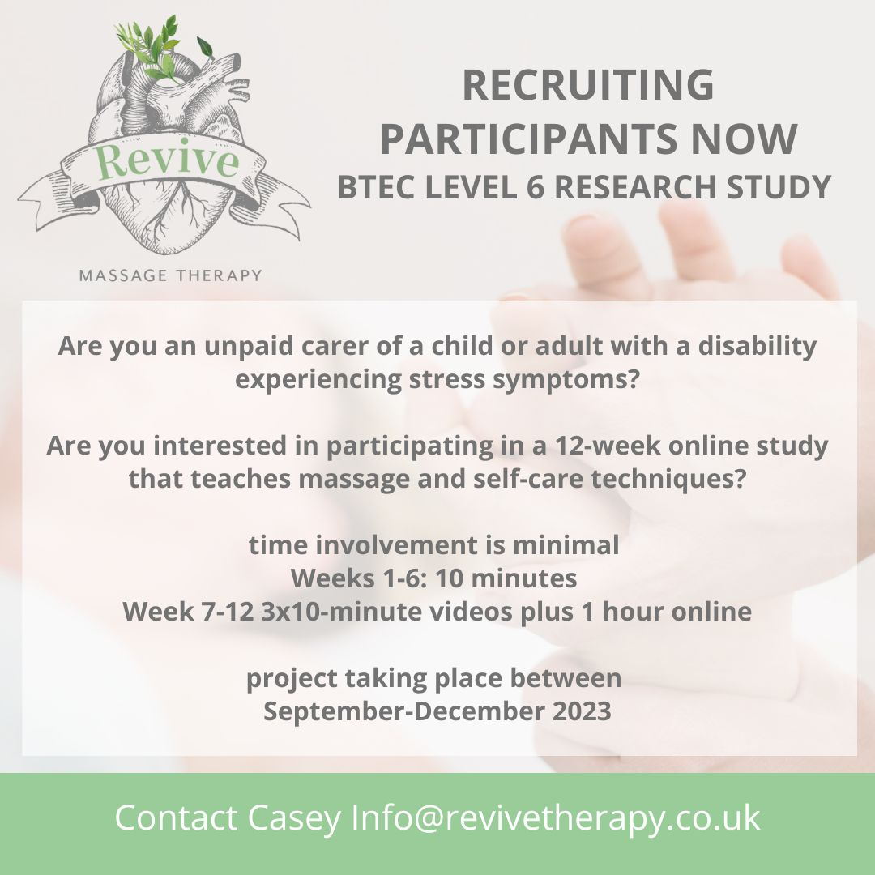

Appendix 3: Consent Form

PARTICIPANT CONSENT FORM

Title of study:

Assessing an online Jing MethodTM Advanced Clinical Massage Protocol to treat stress in unpaid carers of children or adults with disability.

Name of student: Casey Stewart-Smith

- I have read the information sheet about this study
- I have had an opportunity to ask questions and discuss this study
- I have received satisfactory answers to all my questions
- I have received sufficient information about this study
- I understand that I am / the participant is free to withdraw from this study: at any time (until such date as this will no longer be possible, which I have been told) Without giving a reason for withdrawing
- That I am free to refuse to answer any question without saying why
- That the services I am receiving will not be affected whether I participate or not.
- I will not record any Zoom calls to respect the confidentiality of other participants
- I understand that some pictures may be taken by the researcher but any identifying features of participants will be anonymized. Please initial here to show that you agree to this:
- I understand that my research data may be used for a further project in anonymous form, but I am able to opt out of this if I so wish, by ticking here
•. I agree to take part in this study
Signed (participant) | Date
Name in block letters:
BTEC students contact details (including telephone number and e-mail address):

Casey Stewart-Smith
Revivetherapy.co.uk
info@revivetherapy.co.uk
07985523570

Appendix 4: DASS-21 Form
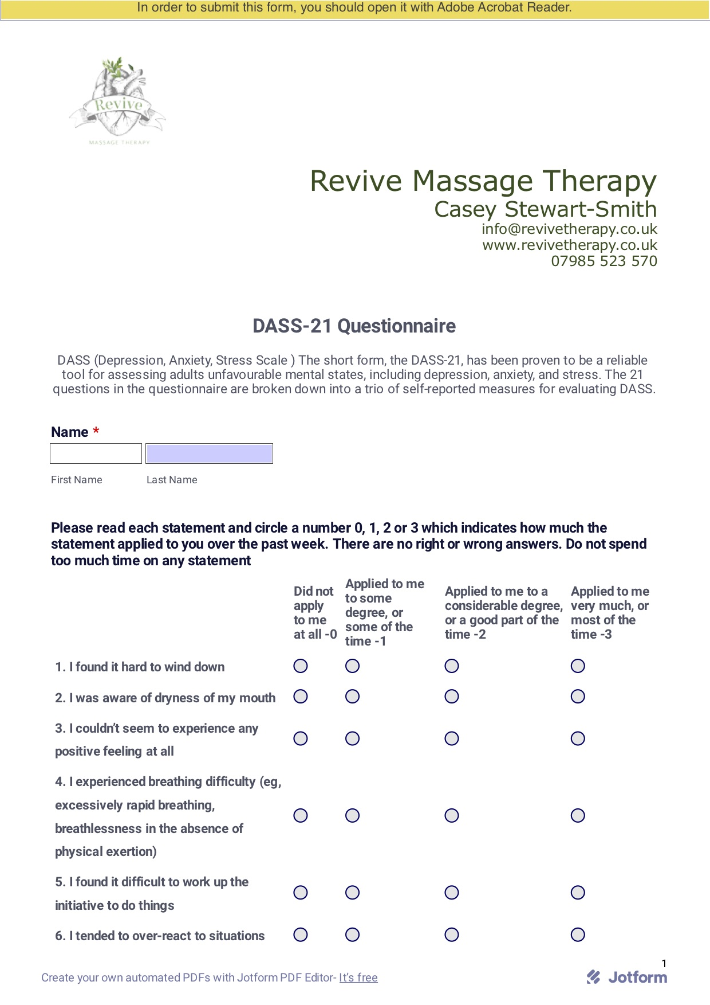
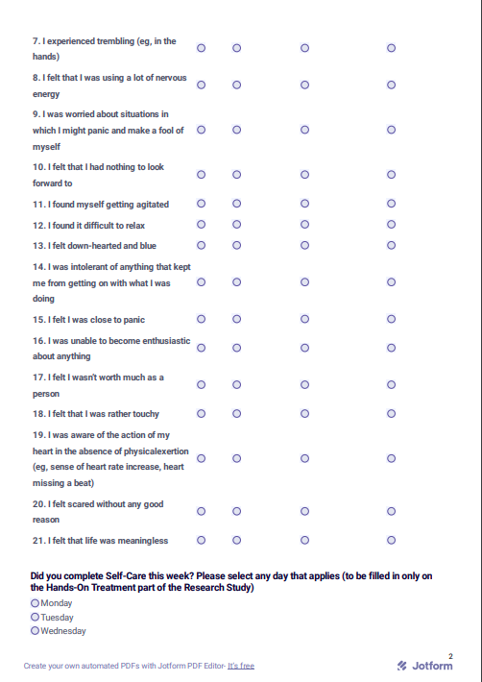

Appendix 5: Intervention protocol

Each Session was 45 minutes long and followed the same format and order each week. The participants were shown how to carry out self-care and massage techniques based on the Jing Method of HFMAST for a different area of the body each session. The ten-minute mindfulness practice was based on the Jing self-help sheets. (Appendix 9)

Format of the weekly sessions:
- Short introductory talk about the area to be worked and possible trigger point referral patterns
- Grounding, concentrating on the breath and short mindfulness session whilst the heated wheat bag warms up the area to be worked.
- Fascial stretches or fascial massage technique appropriate to the area
- Self-massage using the tennis ball or hands to the relevant muscles
- Demonstration of how to find and hold the appropriate acupressure points
- Stretches for the muscles of the area
- Ten-minutes of mindfulness/relaxation, based on the Jing self-care sheets
jingmassage.com/wp-content/uploads/2015/11/jing-sheet-2.pdf
jingmassage.com/self-care-resources-for-massage-therapists/body-scan/
- Teach what they need to do for self-care before the next session.

Appendix 6: Intervention timetable

Table showing the different areas of the body
worked during the intervention period
week 7-12 of study

Week 7 | Neck and shoulders
Week 8 | Low back
Week 9 | Upper back and shoulders
Week 10 | Legs and feet
Week 11 | Arms and hands
Week 12 | Head, neck and face

Appendix 7: Participant feedback

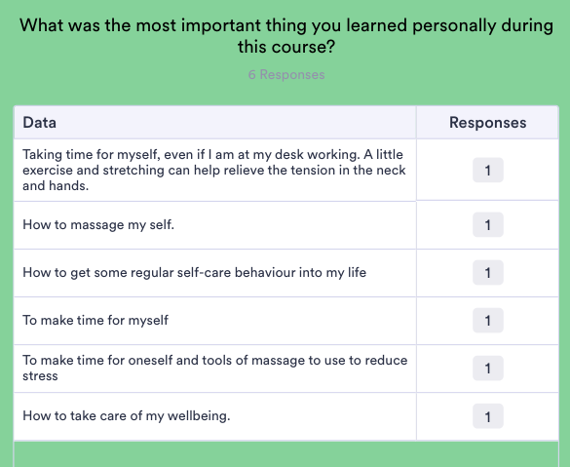
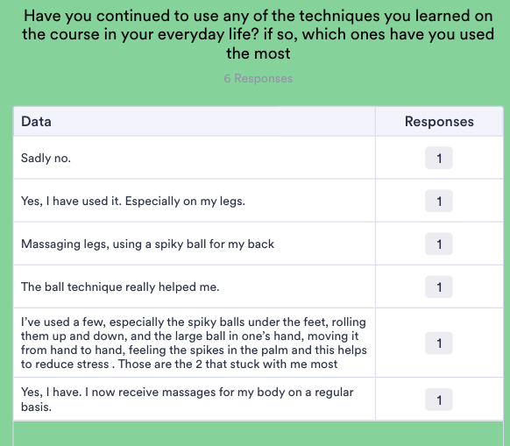

“I really enjoyed the course and doing it every week helped me reduce stress especially as at the time I needed relaxation as I was very stressed.
Casey was kind and patient and supportive throughout the course”

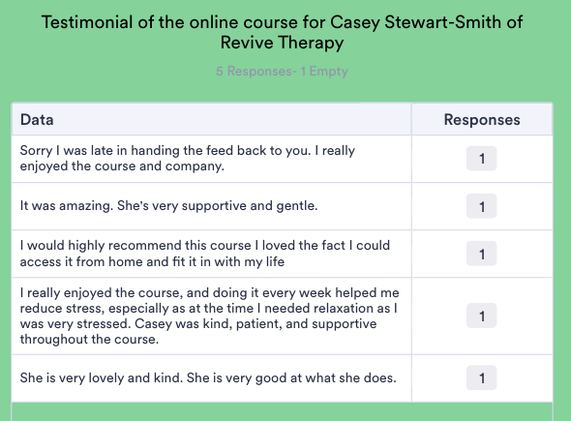

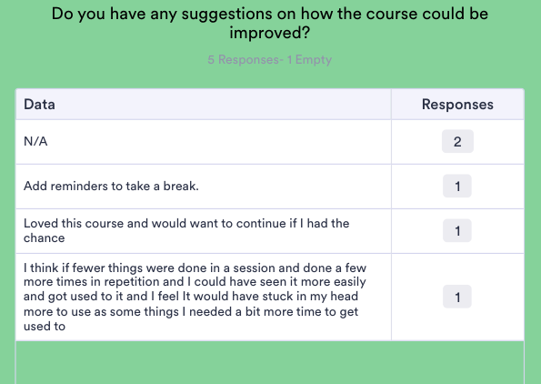

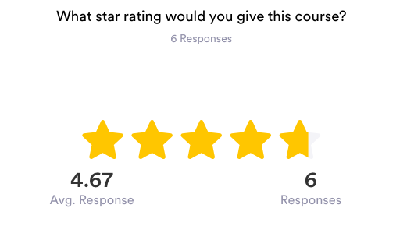

Appendix 8: Breathing technique graphics

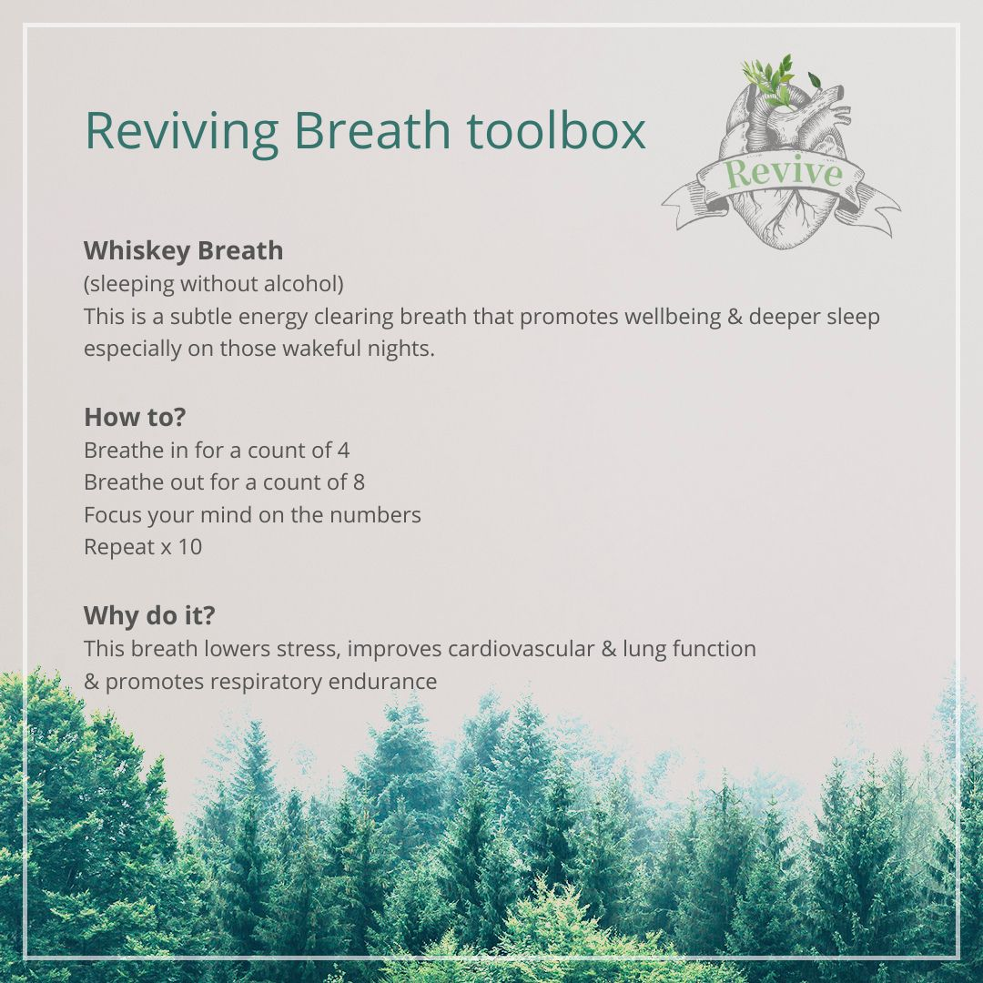

Appendix 9: Example stills from week 1 intervention (week 7 of study)

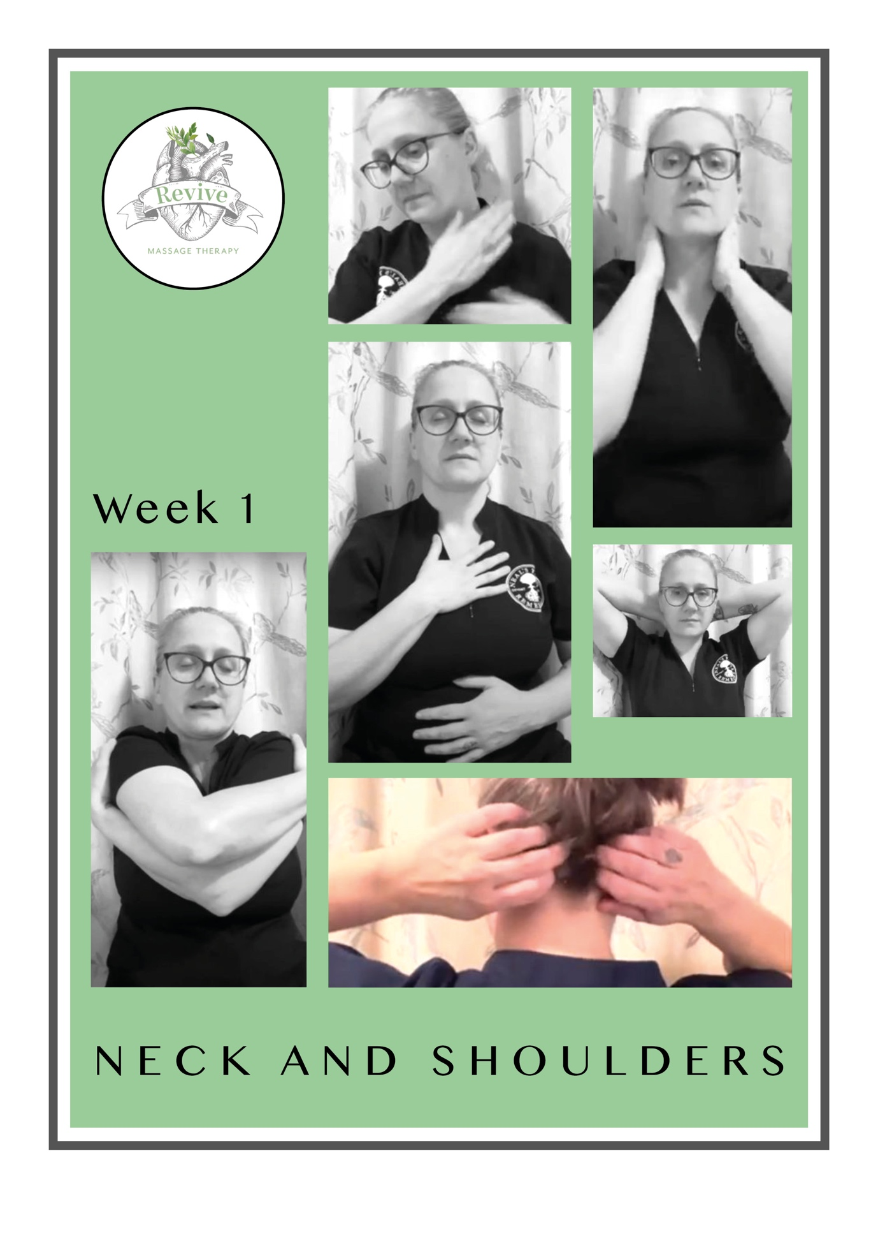

Appendix 10: Contact Details and downloadable study QR Code

